Code pipeline
- Managed workflow for continuous code deployment.
- GUI based
- Integrated with different code repositories
  - Github, Aws code commit, S3
- Pipelines are models of automated release processes. Each pipeline is uniquely named, and consists of stages, actions, and transitions.

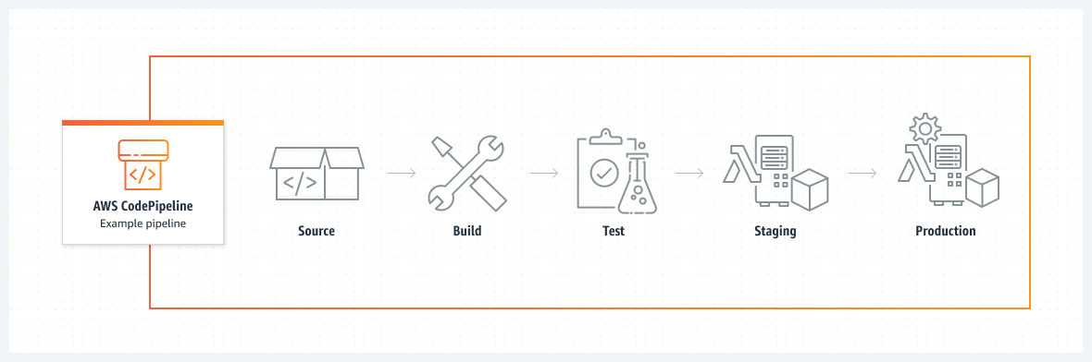

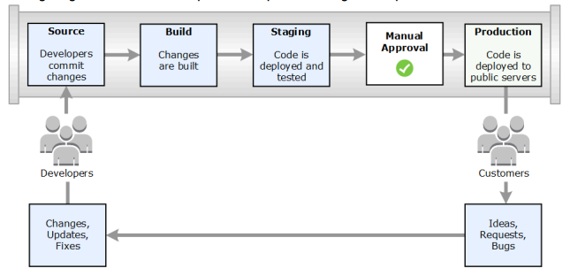
- stages . Each stage contains one or more actions that must complete before the next stage begins. A stage results in success or failure
- actions- is a defined behaviour. Jobs , which are instances of an action.
  - Source
  - Build
  - Test
  - Deploy
  - Approval
  - Invoke
- Transition – allowing passage of artifacts either true or false
- Price $1/active pipeline/month

AWS code commit |  | Build and test  Code Build | Staging  Lambda | Production
Github
AWS ECR | Code pipeline
S3

Code commit
- Collaborative, scales
- 5 users free
- Integrations with code pipeline

